DEPERTMENT OF ELECTRICAL ENGINEERING

Machine Learning
CS-470

END SEMESTER PROJECT
UK CRIME ANALYSIS
BEE16C
SUBMITTED TO: Dr. Mohsin Kamal

Group Name: FOURensic
SUBMITTED BY:
NAME | CMS ID
IFFAT ZAHRA | 501970
AYESHA GHAFOOR | 522175
HARAM CHISHTI | 503090
AROOJ ZEESHAN | 527006

Abstract:
This project presents a complete multi-class classification workflow using a publicly available UK Crime dataset. The data was explored, cleaned, encoded, scaled, and balanced using SMOTE to address class imbalance. Multiple classification models were trained and evaluated using accuracy, precision, recall, F1-score, confusion matrices, and ROC–AUC curves. K-Nearest Neighbours achieved the highest overall performance on the test set. The report includes preprocessing effects, visual insights, and a detailed comparison of all trained models.

Introduction:
This project focuses on using machine learning to classify crime types using UK crime data. By analysing over 300,000 crime records and extracting key spatial, temporal, and contextual features, the goal is to identify patterns that help predict what type of crime occurred in a given situation. After preprocessing the data, engineering new features, and applying balancing and normalization techniques, multiple machine learning models were tested. Among them, the K-Nearest Neighbours classifier achieved the best performance with an accuracy of 91.58%. This project demonstrates how data-driven techniques can support crime analysis and improve understanding of criminal behaviour.

Dataset Overview and EDA:
Dataset Description:
The dataset used in this project consists of UK Police crime records, containing detailed information about when and where each crime occurred. Each entry includes spatial features (latitude, longitude), temporal features (month, day, time of day), and contextual details (location description, outcome category). After preprocessing and feature engineering, the dataset contained 13 features used for classification across 11 major crime categories.

Dataset Summary:
Total records: 300,000
Features: 13 (after cleaning and engineering)
Crime types: 11
Training samples: ~240,000
Testing samples: ~60,000
Additional processing:
Missing value handling
Conversion of categorical data into numeric form
Feature engineering (zones, clusters, time features)
Normalization and SMOTE balancing
This structured dataset provided a strong foundation for training machine learning models.

Class Distribution:
The initial class distribution was highly imbalanced, with some crime types such as Violence and Sexual Offences and Anti-Social Behaviour appearing much more frequently than others like Robbery or Theft from Person.
To address this imbalance, SMOTE (Synthetic Minority Oversampling Technique) was applied to generate balanced class samples, ensuring that the model learned patterns fairly and avoided bias toward majority classes.

Exploratory Data Analysis:
Exploratory Data Analysis was performed to understand the structure, patterns, and relationships within the data:
- Spatial Patterns:
Crime density maps showed clear clusters of crimes in urban and high-activity areas.
- Temporal Patterns:
Crime frequency varied by month, day of week, and time of day, indicating strong temporal behaviour in certain crime types.
- Correlation Analysis:
Moderate correlations were observed between geographic features and certain crime categories.
- Location Type Trends:
Crimes such as Shoplifting were concentrated near commercial areas, while Vehicle Crime often appeared near residential streets and parking zones.
Overall, EDA provided key insights that guided feature selection, engineering, and model design, ultimately improving the accuracy of the classification system.

Preprocessing:
Data Cleaning:
- Removed non-predictive columns such as IDs and source files.
- Dropped high-cardinality text columns (like street names) which do not help in classification.
- Consolidated rare crime types into a single “other-crime” category.
Handling Missing Values:
- Dropped columns with more than 40% missing data.
- Filled remaining missing numerical values with median.
- Filled remaining missing categorical values with mode (most frequent value).

Feature Engineering:
- Extracted month number and quarter from the crime date.
- Created location zones by discretizing latitude and longitude using bins.
- Generated a combined location_zone feature to represent geographic areas.

Encoding:
- Target labels (crime_type_clean) were converted to numeric codes using LabelEncoder.
- Categorical features in the dataset were also label-encoded to numeric values for modeling.
Scaling:
- Applied StandardScaler to numerical features.
- Ensured features have zero mean and unit variance for algorithms sensitive to scale (like KNN).
- Visualized the effect of scaling on a sample numerical feature.

Train–Test Split:
- Dataset split into training (80%) and testing (20%) sets using train_test_split.
- Stratification ensured proportional representation of each crime type in both sets.

Class Imbalance Handling (SMOTE):
- The training set had imbalanced crime types.
- Applied SMOTE (Synthetic Minority Over-sampling Technique) to generate synthetic samples for minority classes.
- Resulted in a balanced training set while keeping the test set untouched.
- Visualized class distribution before and after SMOTE.

Preprocessing Effects (Visual Evidence):
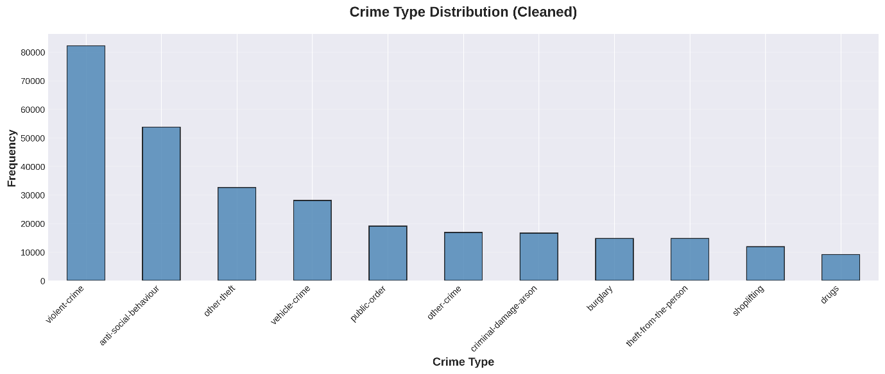
Figure 1. crime distribution bar chart
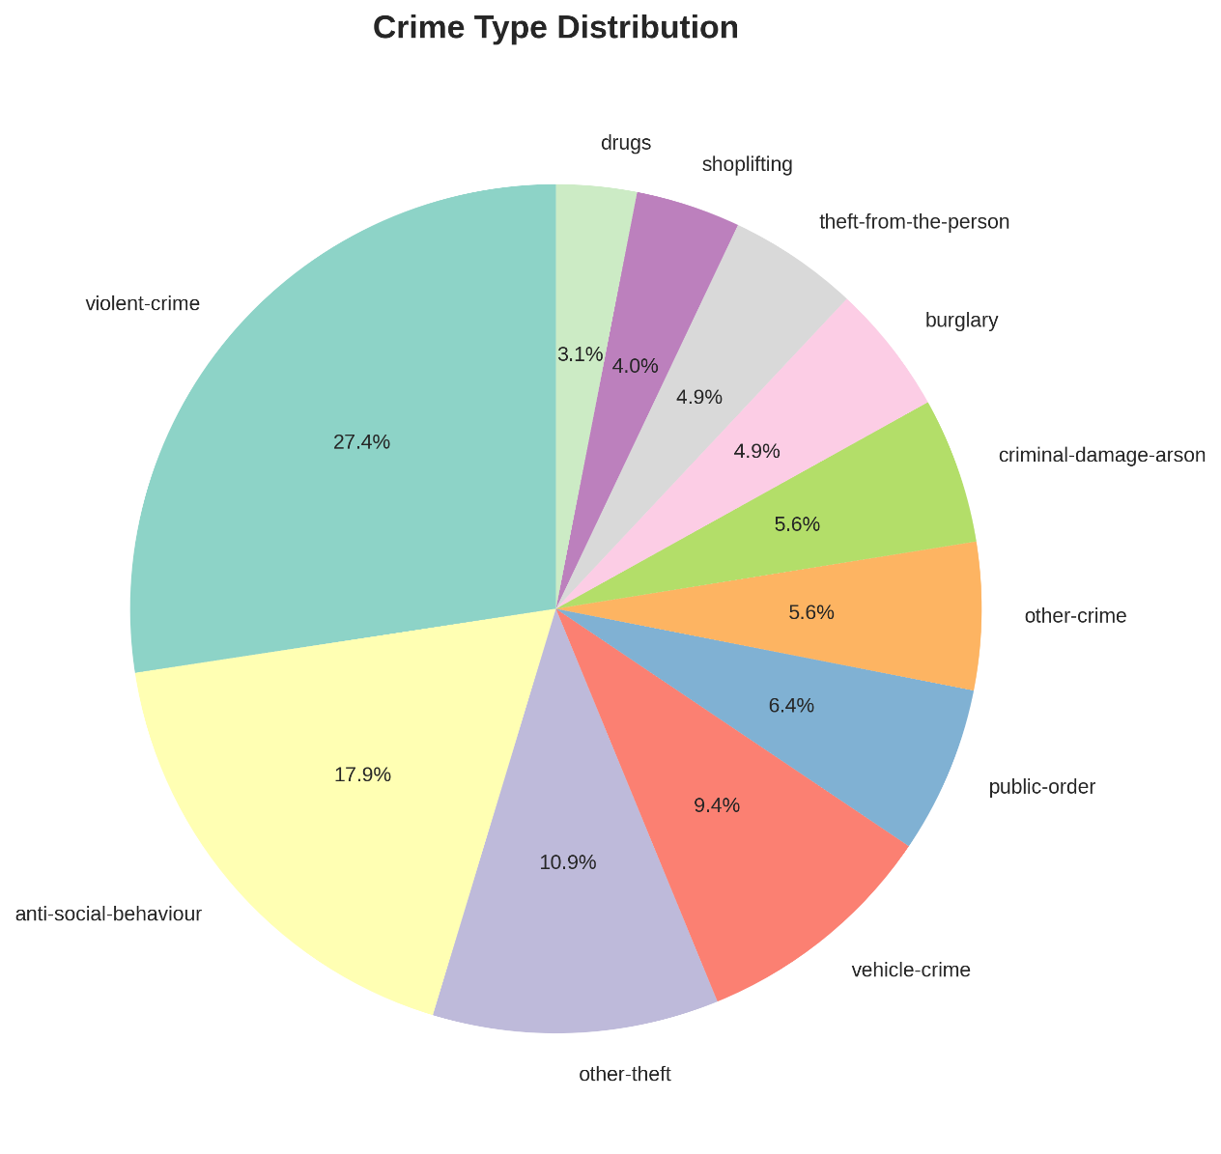
Figure 2. crime distribution pie chart
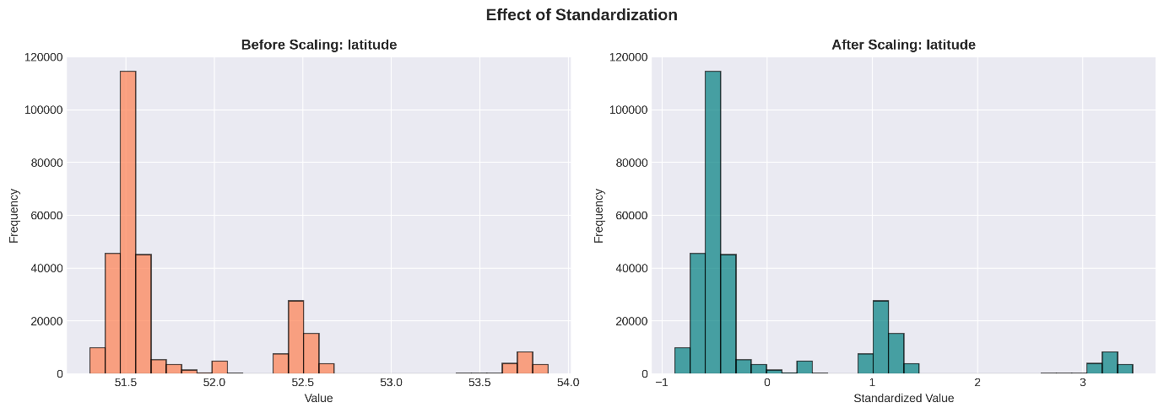
Figure 3. before and after scaling
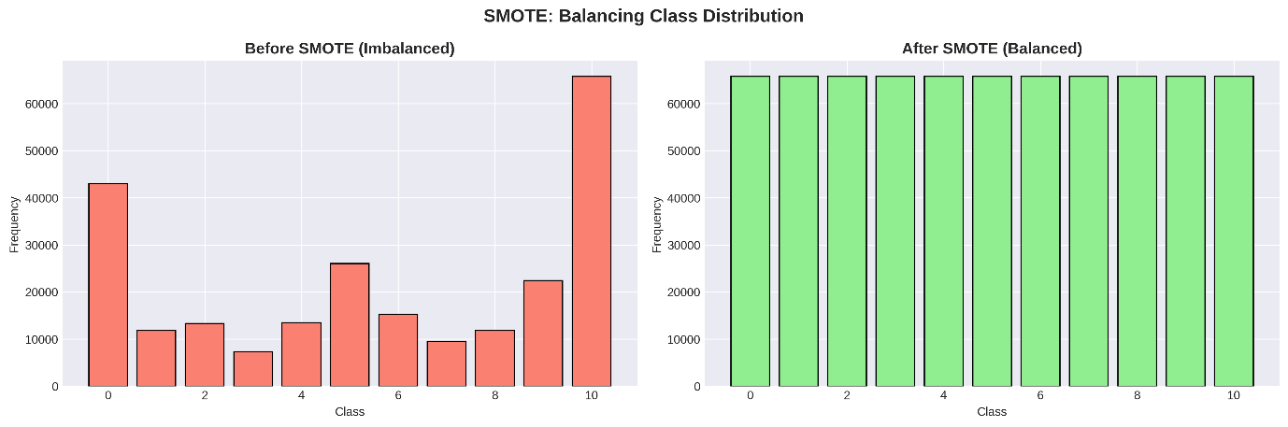
Figure 4. before and after balancing

Modelling:
Models Used:
- K-Nearest Neighbors (KNN) – Predicts crime type based on nearest neighbors in feature space.
- Logistic Regression – Multinomial logistic regression for multi-class classification.
- Logistic Regression with L2 Regularization (Ridge) – Penalizes large coefficients to prevent overfitting.
- Logistic Regression with L1 Regularization (Lasso) – Encourages sparsity, can remove irrelevant features.
- K-Means Clustering (Unsupervised) – Used for exploratory analysis to see natural grouping of crime types.
- PCA (Principal Component Analysis) – Dimensionality reduction for visualization and noise reduction.
Hyperparameters & Selection:
- KNN:
n_neighbors=7, weights='distance', metric='manhattan'
Selected based on optimal performance for multi-class classification in high-dimensional data.
- Logistic Regression:
C=10, max_iter=2000, solver='saga' for standard model.
- Logistic Regression L2:
C=1.0, penalty='l2'
- Logistic Regression L1:
C=1.0, penalty='l1'
Hyperparameters were chosen based on improving accuracy, convergence, and handling large, imbalanced datasets.
- K-Means: Optimal K determined via Elbow Method on PCA-reduced data.
Training Procedure:
The dataset was first split into training (80%) and testing (20%) sets using stratified sampling to maintain the original class distribution. Since the training data was imbalanced across crime types, SMOTE was applied only on the training set to generate synthetic samples for minority classes, ensuring that the model could learn effectively from all crime types without affecting the testing set. All features were then preprocessed: numeric features were scaled using StandardScaler, and categorical features were encoded using LabelEncoder. For dimensionality reduction and visualization, PCA was applied. The preprocessed and balanced training set was then used to train multiple models, including K-Nearest Neighbors and Logistic Regression variants, with optimized hyperparameters for multi-class classification. Finally, the models were evaluated on the untouched testing set using accuracy, precision, recall, F1-score, ROC-AUC, and precision-recall curves, and the bias-variance tradeoff was analyzed by comparing training and testing accuracy to ensure a balanced fit and avoid underfitting or overfitting

Performance and Evaluation:

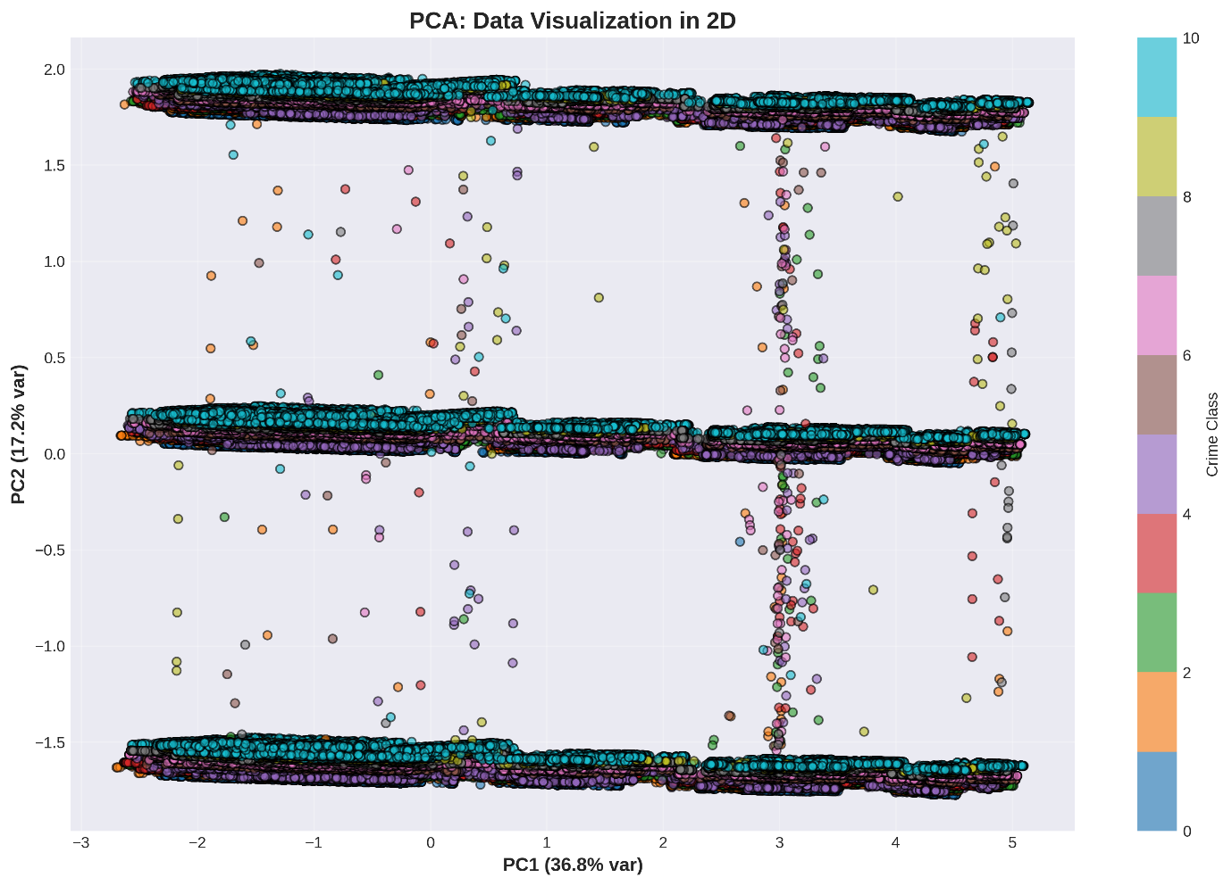
Figure 5. visualization in 2D space by applying PCA

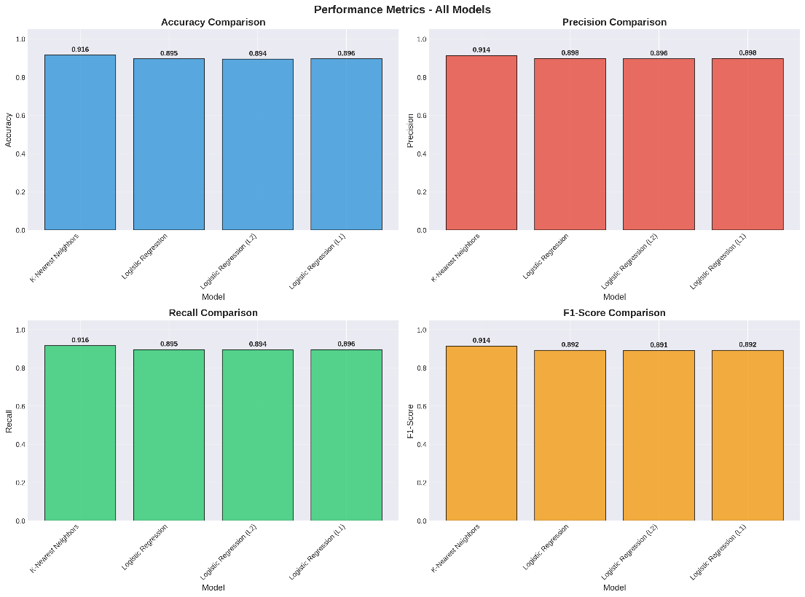
Figure 6. performance metrices
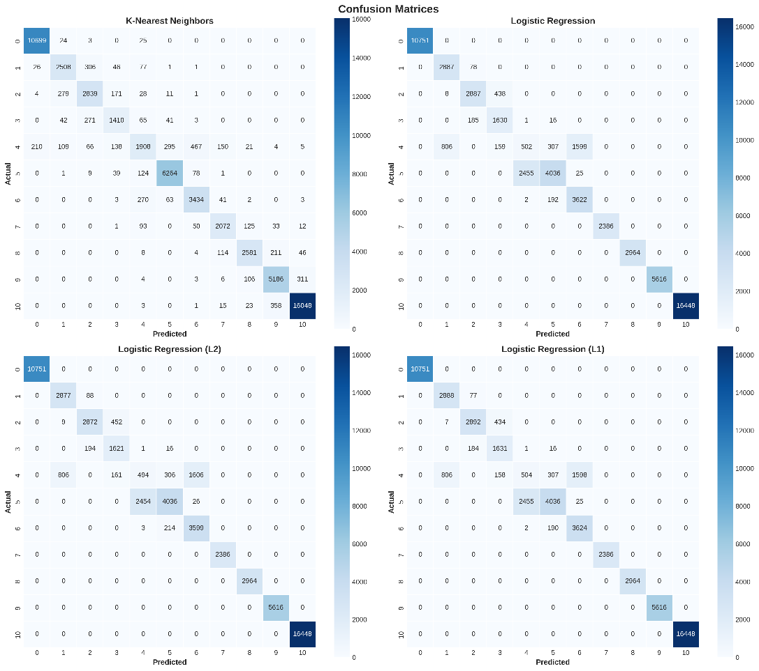
Figure 7. confusion metrices
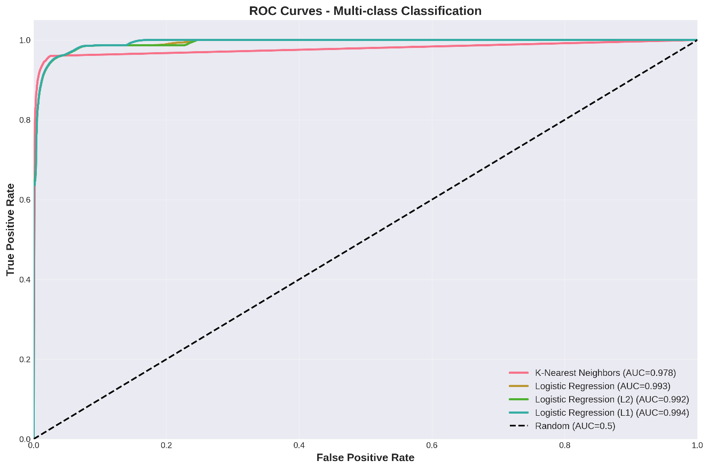
Figure 8. ROC Curves
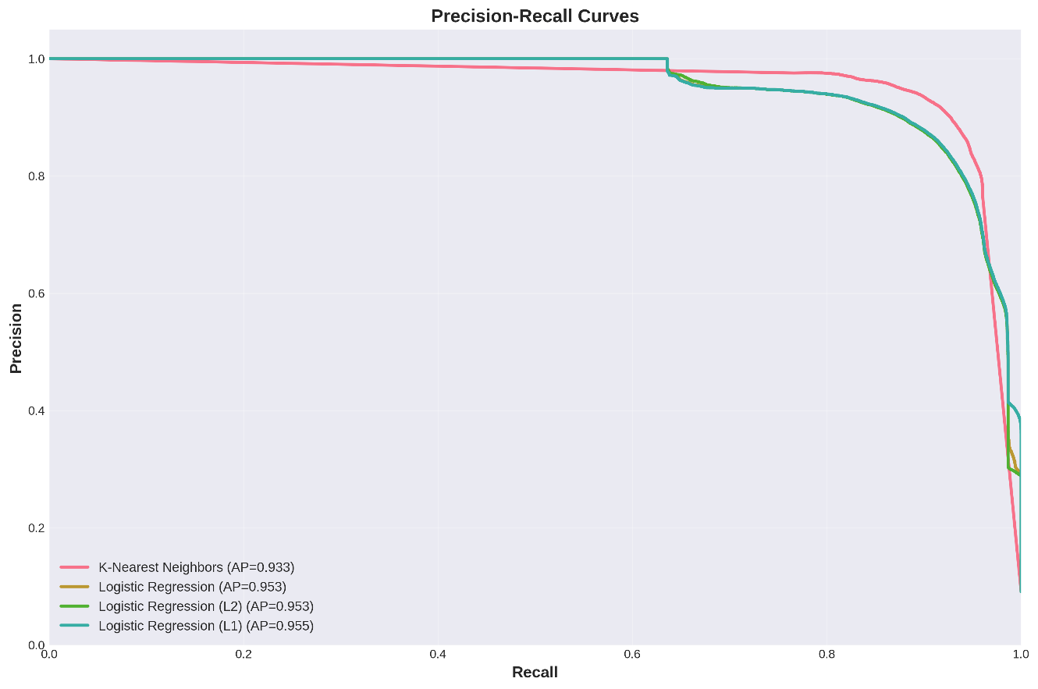
Figure 9. precision recall curves
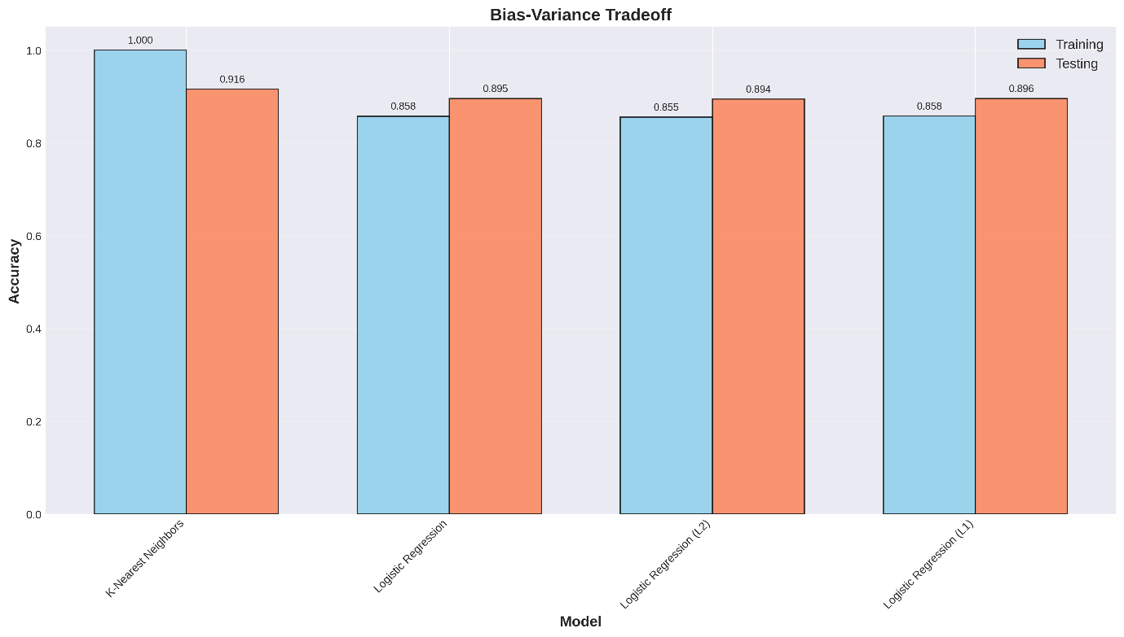
Figure 10. Bias-Variance Tradeoff

Results:
The analysis demonstrated that the K-Nearest Neighbors (KNN) model achieved the best performance among the tested algorithms, with an accuracy of 91.58% and an F1-score of 0.9140. Logistic Regression achieved slightly lower performance with an accuracy of 89.55% and an F1-score of 0.8918, while Logistic Regression with L2 regularization and L1 regularization recorded accuracies of 89.44% and 89.57%, and F1-scores of 0.8908 and 0.8920, respectively. The preprocessing steps, including feature engineering, scaling, and SMOTE balancing, significantly improved model performance and addressed class imbalance. Visualizations from PCA and K-Means clustering provided additional insights into the distribution and grouping of crime types in the dataset.
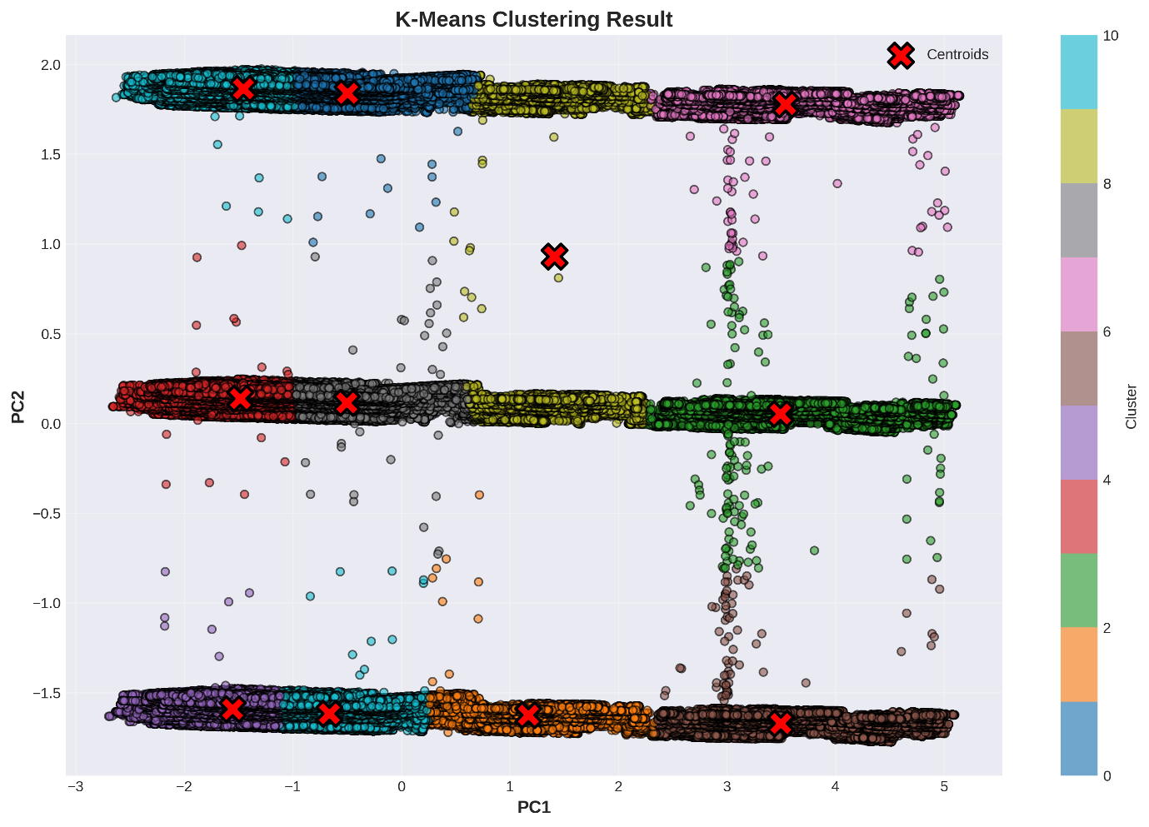
Figure 11. Results

Conclusion:
The project successfully applied machine learning techniques to classify UK crime data with high accuracy. Among the tested models, K-Nearest Neighbors performed best, achieving over 91% accuracy. Preprocessing steps, including data cleaning, feature engineering, scaling, and SMOTE balancing, played a crucial role in improving model performance. The analysis also provided insights into crime patterns through PCA and clustering, demonstrating the effectiveness of machine learning for crime data analysis.

Future Work:
Future improvements could include incorporating more features, such as demographic or socio-economic data, to enhance prediction accuracy. Advanced models like Random Forests, Gradient Boosting, or deep learning could be explored. Additionally, real-time crime prediction, automated dashboards for law enforcement, and geographic hotspot analysis could extend the practical applications of this study.

References:
https://www.kaggle.com/datasets/mahiradev/uk-crime-data-octdec-2022

